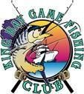2021 Dampier Classic
T&R Gamefish Section Rules

- Line classes for T&R Gamefish shall be limited to a maximum of 15kg. The Tournament Committee reserves the right to inspect and/or test any rod, Reel, rig or tackle used in the tournament.

- Only IGFA rated and factory tested Mono will be accepted. The only exception to this is IGFA factory tested Dacron. The use of backing is permissible, i.e. Braid, Dacron or Monofilament line. The catch shall be classified under the breaking strength of the first five meters of the line directly preceding the double, leader & hook. This section must be comprised of a single homogenous piece of line.

- When a billfish is tagged regardless of which section It must be radioed to King Bay Base stating the following:
  - Species
  - Angler
  - Time of tagging
  - Estimated weight
  - Line class
  - The section the tags is being nominated for
At this time the angler may be asked to present the gear for inspection when next at the weigh station. If staying overnight this may not be possible until the following day.

Tag cards can be presented at the weigh in daily, fish tagged on one day but handed in the following day will count for the day that they are handed to the weigh master. Radioed billfish tag cards are not considered authenticated until they are receipted by the Weigh master.

This year we will also be having a daily tag sheet for the T&R sections. This sheet must be filled out by the angler prior to going to the weigh master in full with boat name, angler, age division, tag number, species and line class. Once complete this sheet along with the anglers tag cards will be presented to the weigh master for cross referencing and then will be signed by the angler and weigh master.

A deposit of $50.00 will be required for the issue of 5 orange Billfish Tags. A Maximum of 20 game fish tags and 5 shark tags will be issued to each team on request with additional tags available on a 1 for 1 basis during the tournament. Additional Game fish/Shark tags above the initial allocation will require a further deposit of $50.00 also refundable on return of unused tags. All unused Tags must be returned at the completion of the Dampier Classic Monday at 7.00pm or the deposit will be forfeited.

- Only in line circle hooks are to be used when live baiting for billfish. KBGFC strongly recommends that stainless steel hooks are not to be used in the capture to tag fish.

- All Billfish must be tagged with - GFAA Tags (Orange Card) to be eligible for points.

- All sharks must be tagged with the GFAA steel tags to be eligible for points. If any other tag is used it will render the tag ineligible and will not count.

- All game fish must be tagged with the GFAA plastic locking tag to be eligible for points. If any other tag is used it will render the tag ineligible and will not count.

- When feasible Game fish eligible for tagging should be brought on board and laid on a damp cool surface (brag mat) measured and tagged with a small deck tagger then returned to the water with a minimum of handling. The NSW DPI has stated that the accurate length of the fish is the most important fact that they need and the estimate of weight is secondary.

Note: Only the 5 highest point scoring tags of each species will count for an individual anglers point score
Note: Only the 5 highest point scoring tags of each species entered by the team will count for that teams point score.

KBGFC Eligible Gamefish Species TAG & RELEASE List and point score matrix

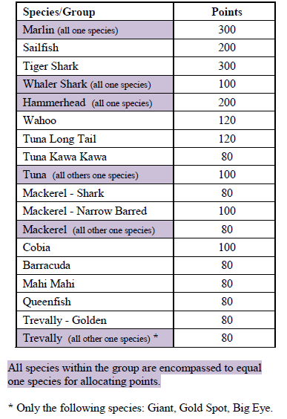

Minimum gamefish size for tagging = 60cm Minimum shark size for tagging = 100cm

Category Rules:

Champion Boat T&R Gamefish: the team with the most points after adding all the qualified tags for that team. Qualified tags will be up to 5 of each species tagged from table above.

Champion Individuals: is the angler with the most points after adding together all the qualified tags entered by the individual angler for their category Male, Female, Junior and Small Fry. Qualified tags will be up to 5 of each species tagged from table above.

Lucky angler daily prizes: will be the angler drawn out on presentation night. Anglers must be present at the presentation to claim this prize. If the angler does not attend a redraw will occur.

To be eligible to win the prize you simply have to enter a fish by either weighing or tagging and hand it to the weigh master for that respective day between weigh in times. Fish will only count for the daily prize on the day they are handed in.
i.e. Fish caught on Friday and weighed during the weigh in times on Friday will count for the Day 1 Fish caught on Friday but weighed during the weigh in times on Saturday will count for the Day 2

And the same for tags, if tagged Friday but handed in on Saturday it will count for the Day 2 prize.
There will be only 1 entry per angler in each draw so you only have to weigh or tag one fish to have an equal chance of winning that day’s prize.

All tag cards for fish captured during Friday and Saturday must be handed in no later than during weigh in on Saturday.
All tag cards for fish captured during Sunday and Monday must be handed in no later than during weigh in on Monday.

